Technical Architecture Draft: Ticket Deflection AI Assistant (WIP)

1. Executive Summary
We are building an embedded virtual assistant (chat pop-up) within our client-facing web portal (CenAccess). The primary business goal is to deflect support tickets by allowing users to ask questions (e.g., mortgage payoff procedures, ACH setup) and receive RAG-backed answers and deep-links to self-service tools.

- User Experience: The user is already logged into the portal via Azure AD B2C. They should never be asked to log in again just to use the chat.
- Security by Design: Browser clients will never hold AI credentials. Users cannot hijack other users' chat sessions.
- Decoupled Intelligence: Our frontend strictly renders UI; all complex workflow orchestration happens deep in the Azure AI Foundry network.

2. Architecture Diagram

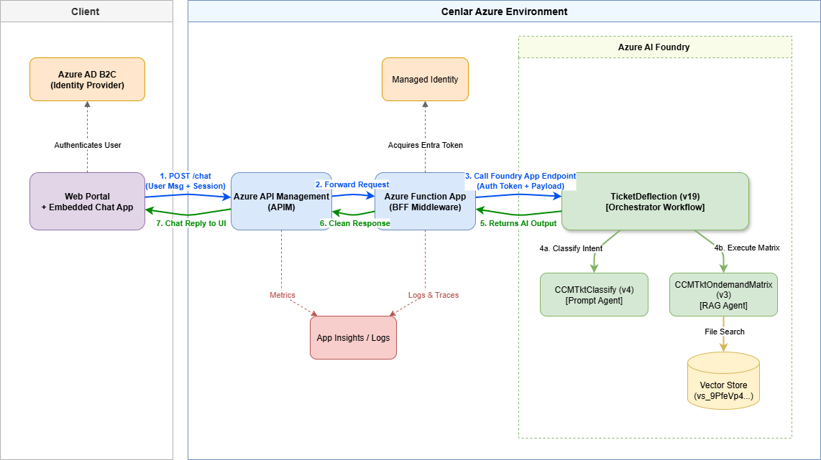

The diagram shows the progression from the Client Environment (Web Portal + B2C) → Azure Gateway (APIM) → Middleware (Azure Function BFF) → Azure AI Foundry Project.]

3. Core System Components
A. The Client Environment (Frontend)
- Web Portal & Chat Widget: A lightweight JavaScript chat UI embedded directly into the authenticated portal.
- Identity Provider: Azure AD B2C. The portal holds a valid B2C JWT token for the user.
- Role: Captures user text, passes the B2C token and a frontend session ID to the backend, and renders the incoming AI text and action links into chat bubbles.
B. Azure API Management - APIM

